**POORNIMA UNIVERSITY, JAIPUR**

**END SEMESTER EXAMINATION, APRIL 2023**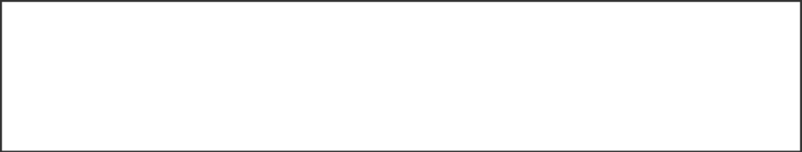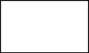

|  |  |  |  |
| --- | --- | --- | --- |
|  | **2BT4218** | Roll No. | Total Printed Pages: 1 |
| **2BT4218** |  |
| B. Tech. II Year IV Semester (Main/Back) End Semester Examination, April 2023  **(CS)** | |
| **BCSCCE4104 : Ethical Hacking** | | | |

# Time: **3** Hours. Total Marks: **60**

Min. Passing Marks: **21**

*Attempt* ***five*** *questions selecting one question from each Unit. There is internal choice from Unit I to Unit V. Marks of each question or its parts are indicated against each question / parts. Draw neat sketches wherever necessary to illustrate the answer. Assume missing data suitably (if any) and clearly indicate the same in the answer.*

Use of following supporting material is permitted during examination for this subject.

# **1.--------------------------Nil--------------------** **2.------------------Nil-----------------------**

|  |  |  |  |
| --- | --- | --- | --- |
|  |  |  |  |

|  |  |  |  |  |
| --- | --- | --- | --- | --- |
|  |  | **UNIT-I (CO1)** | **Marks** | **Bloom Level** |
| **Q.1** | **(a)** | Discuss any three common vulnerabilities with respect OWASP. | **(6)** | **Analyze** |
|  |  |  |  |  |
|  | **(b)** | Discuss penetration testing? Explain. Why is it required? | **(6)** | **Understand** |
|  |  | **OR** |  |  |
| **Q.2** | **(a)** | Explain in detail the challenges of information security. | **(6)** | **Remember** |
|  |  |  |  |  |
|  | **(b)** | Explain the idea of ethical hacking. | **(6)** | **Analyze** |
|  |  | **UNIT-II (CO2)** |  |  |
| **Q.3** | **(a)** | Discuss the concept of using port scanning in Nmap with example. | **(6)** | **Understand** |
|  |  |  |  |  |
|  | **(b)** | Explain DoS attack with example. | **(6)** | **Analyze** |
|  |  | **OR** |  |  |
| **Q.4** | **(a)** | Define ransom ware and its impact on different applications with example. | **(6)** | **Remember** |
|  |  |  |  |  |
|  | **(b)** | Explain burp suite with example. | **(6)** | **Analyze** |
|  |  | **UNIT-III (CO3)** |  |  |
| **Q.5** | **(a)** | Discuss any three security testing tools for vulnerability analysis. | **(6)** | **Remember** |
|  |  |  |  |  |
|  | **(b)** | Discuss A1, A6, A3 and A9 vulnerabilities with respect to OWASP 2013. | **(6)** | **Understand** |
|  |  | **OR** |  |  |
| **Q.6** | **(a)** | Discuss A2, A7, A3 and A4 vulnerabilities with respect to OWASP 2022. | **(6)** | **Understand** |
|  |  |  |  |  |
|  | **(b)** | Explain intrusion detection system? How does it work? | **(6)** | **Remember** |
|  |  | **UNIT-IV (CO4)** |  |  |
| **Q.7** | **(a)** | Explain Social Engineering? What type of behaviors can be vulnerable to social engineering attacks? | **(6)** | **Analyze** |
|  |  |  |  |  |
|  | **(b)** | Explain Information gathering and tools which use for this purpose. | **(6)** | **Remember** |
|  |  | **OR** |  |  |
| **Q.8** | **(a)** | Explain the following techniques of firewall identification:  a) Port scanning b) Banner grabbing | **(6)** | **Understand** |
|  |  |  |  |  |
|  | **(b)** | How can web site login be bypassed using SQL injection? Explain with example. | **(6)** | **Analyze** |
|  |  | **UNIT V (CO5)** |  |  |
| **Q.9** | **(a)** | Explain Report Writing & Mitigation in hacking. | **(6)** | **Understand** |
|  |  |  |  |  |
|  | **(b)** | Make a report using Indus face WAS for any one website. | **(6)** | **Remember** |
|  |  | **OR** |  |  |
| **Q.10** | **(a)** | Make a report using acuntix for any one website. | **(6)** | **Analyze** |
|  |  |  |  |  |
|  | **(b)** | Differentiate low level and high level penetration testing result reporting. | **(6)** | **Understand** |